Je m’appelle: _______________________ La date: _________________

Les prépositions + Les noms
Prepositions + nouns

Definition: A preposition is a word or words which show position, direction, or relation of one thing to another.
Near, on, under, on the left, far from = près de, sur, sous, à gauche de, loin de

Definition: A noun is a person, place, thing, or idea. Nouns are the words that come after “the” or “a” in English and “le/la/les” or “un/une” in French.
The family, a pencil, the boys = la famille, un crayon, les garçons

Why am I learning this? Nouns and prepositions go together like bread and butter. Here’s an example. Prepositions underlined, nouns bolded:
Le crayon est sur le bureau. The pencil is on the desk
Le bureau est à gauche de la porte. The desk is to the left of the door.

Usually sentences like the one above can be translated word-for-word fom English. Try it! Use your blue vocab sheet, it has every word you need.
1. The pen is under the chair. _______________________________________
2. The pencil sharpener is on the table. ____________________________________
3. The Kleenex is next to the eraser. _____________________________________
4. The poster is between the board and the desk. ____________________________________________
5. The book is on the shelves. __________________________________________________
6. The shelves are under the board. ____________________________________________
7. The book is in the classroom. ____________________________________________

Did that seem kind of easy? I hope so! This is one of those times French is just like English.

BUT WAIT, PLOT TWIST. Sometimes it’s not like English. Which of the prepositions that we have learned end with the word “de?” Write them below.

ANY PREPOSITION THAT ENDS IN “DE” HAS AN EXTRA RULE TO REMEMBER. Let’s use à côté de (next to) as our example. When à côté de is followed by a noun that has “le” or “les” in front of it, it will change.
DE + LE = DU DE + LES = DES

Examples:
The book is next to the desk = le livre est à côté du bureau
The pencil is to the left of the pen = le crayon est à gauche du stylo
The pencil is to the right of the pens = le crayon est à droite des stylos
Try it!
- The poster is to the right of the pencil sharpener.
__________________________________________________________________________
- The backpack is next to the shelves.
__________________________________________________________________________
- The binder is next to the notebook.
__________________________________________________________________________
- The pen is next to the board.
__________________________________________________________________________

Je m’appelle: _______________________ La date: _________________

DEVOIR FR2: Les prépositions + Les noms

Part I : Practicing the vocab. Put together the noun + preposition. Watch out for de + le (du) and de + les (des). The rest don’t change at all !

- À côté de + la porte = ___________________________________
- À droite de + le bureau = __________________________________
- À droite de + le pupitre = __________________________________
- À gauche de + l’ordinateur = __________________________________
- À côté de + les stylos = ___________________________________
- À côté de + les chaises = ________________________________

Part II : Translate from French to English. « Il y a » = there is/are.

- Il y a un crayon sous le pupitre.
______________________________________________________________
- Il y a deux feutres sur le bureau.
______________________________________________________________
- Il y a une gomme sur le crayon.
______________________________________________________________
- Il y a une chaise à côté du tableau.
______________________________________________________________
- Il y a un chien sur l’ordinateur !
______________________________________________________________
- Le prof est sous le bureau.
______________________________________________________________
- Le stylo est dans le livre.
______________________________________________________________

Part III : English to French (is = est, are = sont)
- The books are next to the door.
______________________________________________________________
- The computer is to the right of the board.
______________________________________________________________
- The notebook is in the binder.
______________________________________________________________
- The pens are in the backpack.
______________________________________________________________
Write 6 sentences about the picture below. Use all of the following at least once:
- Sous, Dans, À droite de, À gauche de, À côté de
You may also need these words: EST = IS, SONT = ARE

1._________________________________________________________________________
2. _________________________________________________________________________
3. _________________________________________________________________________
4. _________________________________________________________________________
5. _________________________________________________________________________
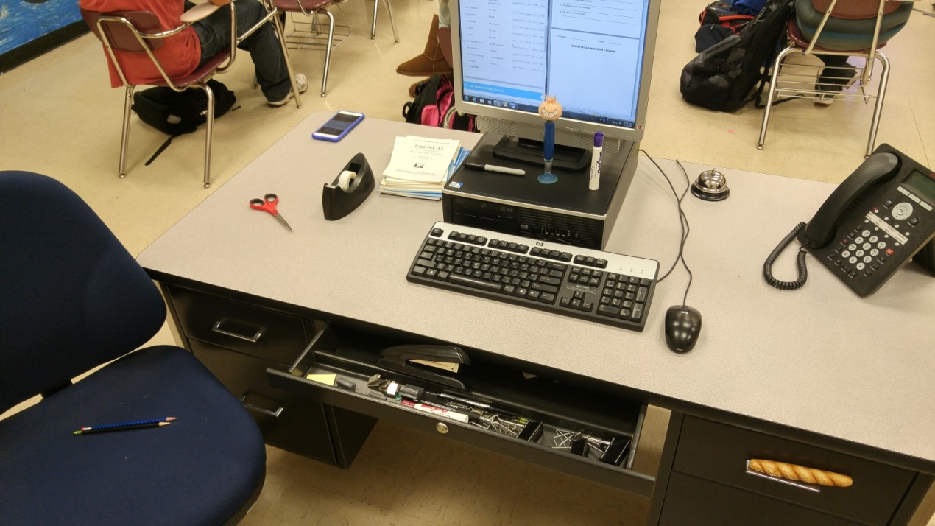
6. _________________________________________________________________________

Je m’appelle: _______________________ La date: _________________
DEVOIR FR3: Les prépositions + Les noms

Part I : Practicing the vocab. Put together the noun + preposition. Watch out for de + le (du) and de + les (des). The rest don’t change at all !

- À côté de + la porte = ___________________________________
- À droite de + les bureaux = __________________________________
- À droite de + le pupitre = __________________________________
- À gauche de + l’ordinateur = __________________________________
- À côté de + le stylo = ___________________________________
- À côté de + les chaises = ________________________________
Part II : Translate from French to English. « Il y a » = there is/are.

- J’ai trouvé un crayon sous le pupitre.
______________________________________________________________
- Il a cherché un feutre sur le bureau.
______________________________________________________________
- Il y a une gomme à côté du crayon.
______________________________________________________________
- Mon ami habite dans un taille-crayon.
______________________________________________________________
- Le petit garçon a deux marqueurs dans son nez !
______________________________________________________________
- Elles ont trouvé un sac à dos près de la porte.
______________________________________________________________
- Chatham est loin de Paris.
______________________________________________________________

Part III : English to French (is = est, are = sont)
- The books are next to the door.
______________________________________________________________
- The computer is to the right of the board.
______________________________________________________________
- The notebook is in the binder.
______________________________________________________________
- The pens are in the backpack.
______________________________________________________________
Write 6 sentences about the picture below. Use all of the following at least once:
- Sous, Dans, À droite de, À gauche de, À côté de, près de, loin de
You may also need these words: EST = IS, SONT = ARE

1._________________________________________________________________________
2. _________________________________________________________________________
3. _________________________________________________________________________
4. _________________________________________________________________________
5. _________________________________________________________________________
6. _________________________________________________________________________

Je m’appelle: _______________________ La date: _________________

DEVOIR FR4: Les prépositions + Les noms

Part I : Practicing the vocab. Put together the noun + preposition. Watch out for de + le (du) and de + les (des). The rest don’t change at all !

- À côté de + la porte = ___________________________________
- À droite de + les bureaux = __________________________________
- À droite de + les pupitres = __________________________________
- À gauche de + l’ordinateur = __________________________________
- À côté de + le stylo = ___________________________________
- À côté de + les chaises = ________________________________

Part II : Translate from French to English. « Il y a » = there is/are.

- J’ai trouvé un crayon sous le pupitre.
______________________________________________________________
- Il a cherché un feutre sur le bureau.
______________________________________________________________
- Il y a une gomme à côté du crayon.
______________________________________________________________
- Mon ami habite dans un taille-crayon.
______________________________________________________________
- Le petit garçon a deux marqueurs dans son nez !
______________________________________________________________
- Elles ont trouvé un sac à dos près de la porte.
______________________________________________________________
- Chatham est loin de Paris.
______________________________________________________________
- Il y a un dragon au-dessus de ma maison.
______________________________________________________________

Part III : English to French (is = est, are = sont)
- The books are next to the door.
______________________________________________________________
- The computer is to the right of the board.
______________________________________________________________
- The notebook is in the binder.
______________________________________________________________
- The pens are in the backpack.
______________________________________________________________
Partie IV : Sur une feuille de papier, écrivez un paragraphe sur la photo. Utilisez TOUTES les prépositions et décrivez la position de TOUS les noms visible dans la photo.

